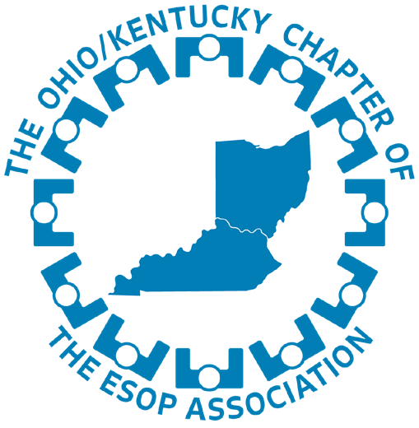
THE OHIO/KENTUCKY CHAPTER OF THE ESOP ASSOCIATION NEWSLETTER

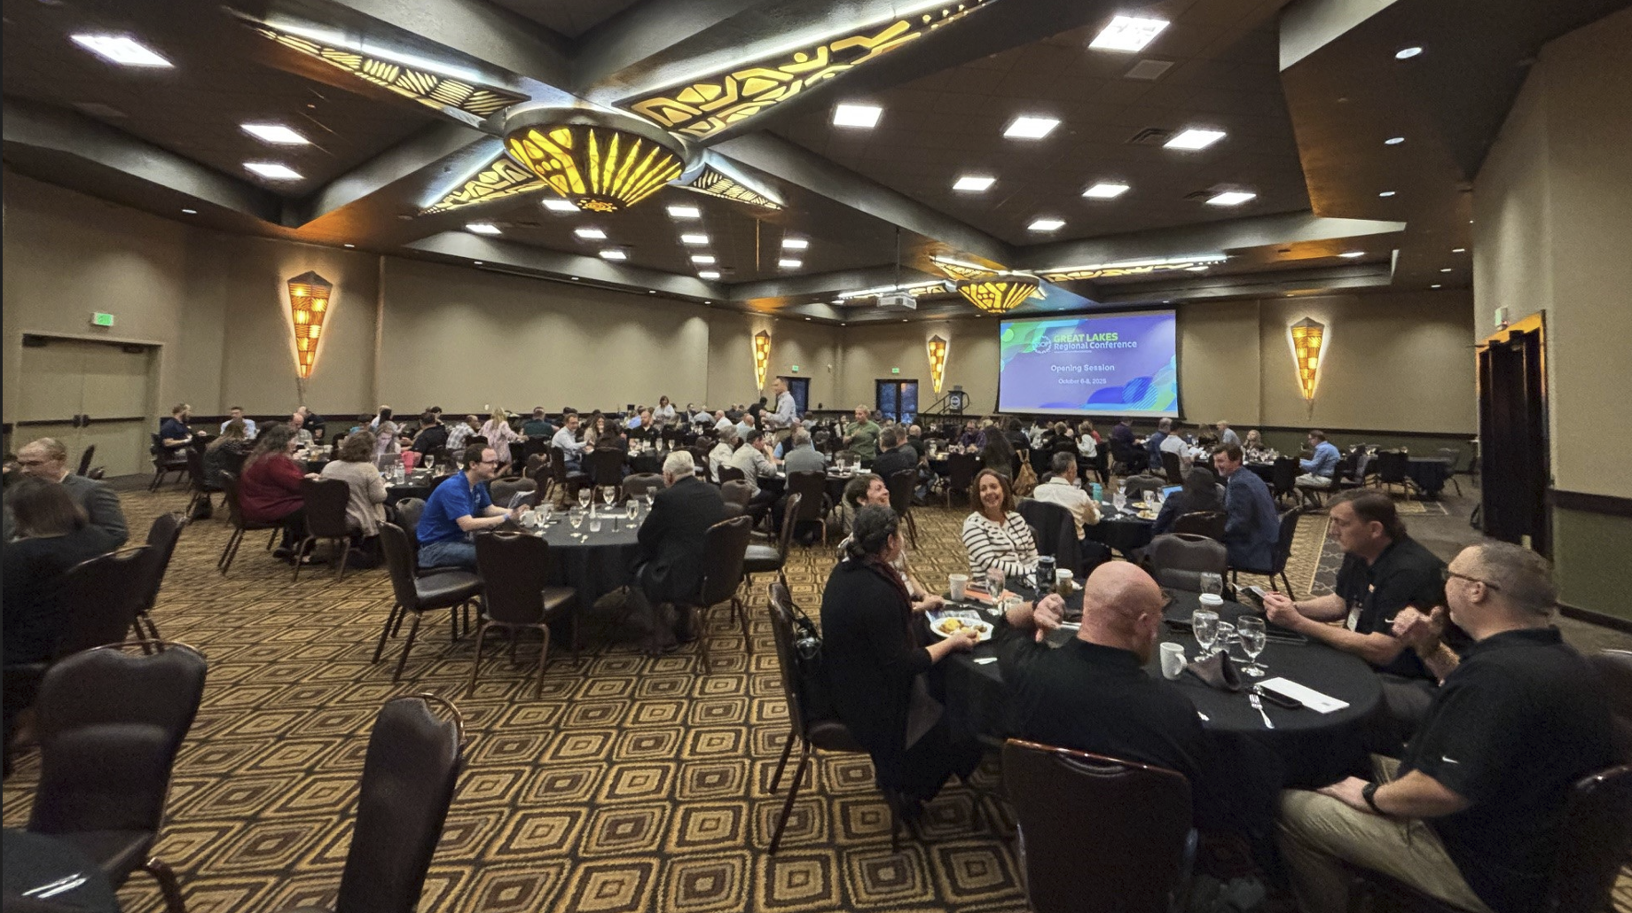

Inside this issue
Recap of Great Lakes
Esopathon Update
Growing EO Culture
Meet Your OH/KY Chapter Officers
Thank Our Sponsors

Send Us Your News!
Have a newsworthy event going on at your company? Share it!
Forward any pictures and/or articles to us, and we’ll share your news with the rest of the Chapter!
Contact Cinnamon King, VP of Communications at cinnamon.king@walkermechanical.com

Great Lakes Regional Conference Recap: A High Energy Gathering of ESOP Leaders
The Ohio/Kentucky Chapter joined the Indiana and Michigan Chapters this past fall at the 2025 Great Lakes Regional Conference, held October 6-8 at the Kalahari Resort & Convention Center in Sandusky, OH. The conference was well attended, with a robust agenda spanning governance, culture, financial literacy, technical topics, and emerging ESOP trends. Attendees had more than 40 breakout sessions to choose from – each designed to provide actionable insights for companies at every stage of their ESOP journey.
A Keynote That Inspired the Room
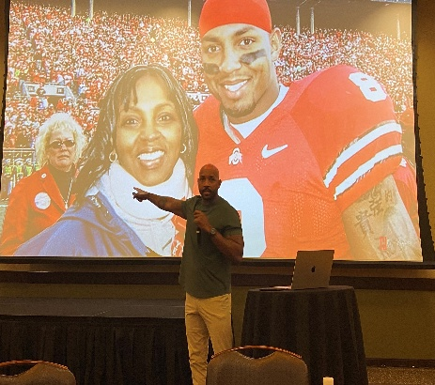
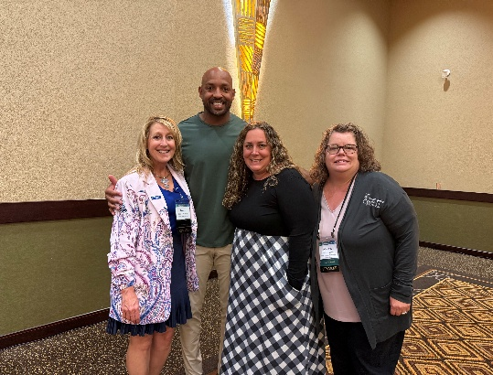
A major highlight was the keynote address delivered by Roy Hall Jr, whose passionate, high energy message challenged and motivated attendees. His focus on personal accountability, leadership, and lifting others resonated deeply.
Looking Ahead
The Great Lakes Regional Conference continues to be a cornerstone event for our ESOP community, and the 2025 gathering proved why. We extend our thanks to all speakers, sponsors, attendees, and volunteers who made the conference memorable and impactful. We look forward to seeing you at next year’s event when it moves to Indianapolis, Indiana at the Sheraton Indianapolis Hotel, September 29th – October 1st.

4 Ways to Grow an Employee Ownership Culture in a Virtual or Hybrid Environment.
Employee ownership thrives on connection, transparency, and shared purpose, all of which can feel harder to cultivate in a virtual or hybrid workplace. But with intention, a strong ownership culture can grow faster online by reaching more people, more often and more consistently. Here are four effective ways to build and sustain employee culture in a virtual or hybrid environment.
- Make ownership Visible and Understandable
Employees can’t act like owners if ownership feels abstract. Regularly communicate what employee ownership means in practical terms - how the business makes money, how decisions are made, and how the individual contributions connect to long-term value. Short videos, dashboards, or virtual town halls can help demystify financials and reinforce that everyone has a stake in outcomes.
- Tie Day to Day Work to Shared Results
In a virtual or hybrid setting, it’s easy for employees to feel isolated. Reinforce ownership by clearly linking individual and team goals to company performance. Use digital tools to track progress, celebrate milestones, and show how collective effort drives success. When employees see the impact of their work, accountability and pride naturally increase.
- Create Moments That Reinforce “We” Over “Me”
Ownership cultures are built through shared experiences. Establish virtual moments such as quarterly ownership updates, peer recognition programs, or virtual shout-outs that highlight collaboration and long-term thinking. Consistent experiences create rhythm and reinforce that ownership is a collective responsibility, not just a benefit.
- Invest in Education and Ongoing Dialogue
Ownership is a mindset that grows over time. Offer regular learning opportunities, such as workshops, Q&A sessions, or small-group discussions, focused on ownership principles, financial literacy, and leadership skills. Just as important, create space for open dialogue where employees can ask questions, share ideas, and influence the future of the organization.
A strong employee ownership culture doesn’t depend on physical proximity. In a virtual or hybrid environment, clarity, consistency, and connection matter more than ever. By making ownership visible, empowering employees, and reinforcing shared success, organizations can build a culture where people don’t just work for the company, they help lead it.

Top Golf Adventures in Cleveland, OH

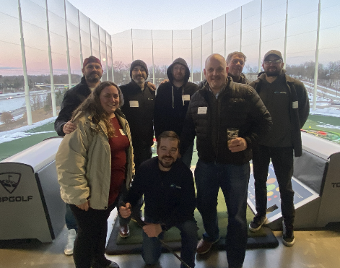
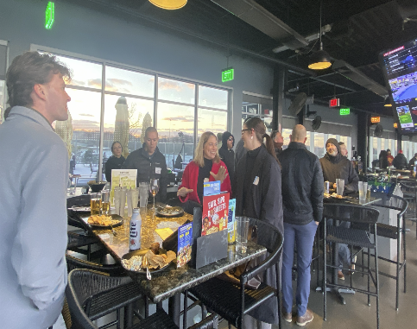
A cold but good time was had by all in December at the get together at Top Golf. Thanks to those that organized and attended!

THANK YOU TO OUR SPONSORS

Upcoming Events
Spring Conference
March 3-4, 2026
Renaissance Columbus Westerville
Polaris, Westerville, OH

TEA National Conference & ESOP Advocacy Day
May 5-8, 2026
Washington, DC

A Strong Year for Fundraising: Silent & Live Auctions Exceed Expectations
One of the biggest successes of the Great Lakes conference was the fundraising effort supporting the Employee Ownership Foundation (EOF). Thanks to the generosity and creativity of donors, attendees, and volunteers, both the silent and live auction delivered record setting results:
- Total fundraising increased 29% over the previous year – from $20,169 to $26,010
- Auction-only revenue (excluding raffles, cornhole and other activities) grew 30%, rising from $18,834 to $24,510.
- The committee secured 81 donated items, up significantly from 65 the prior year.
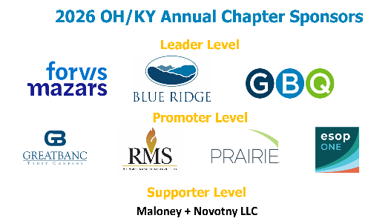
- Live auctions items grew from 13 to 18, expanding participation and boosting competition.
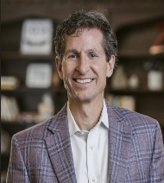
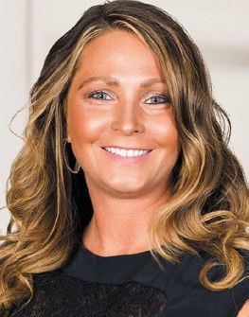
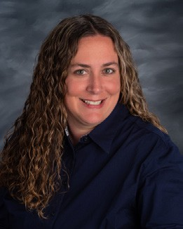
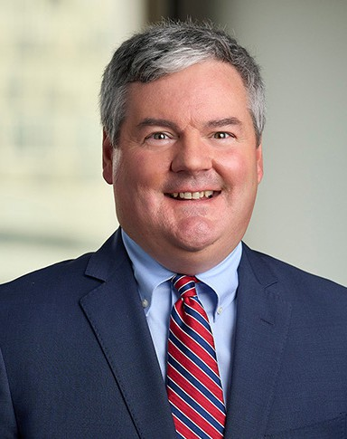

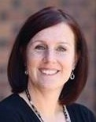
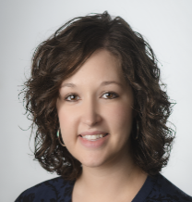
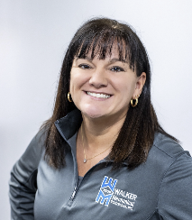
- Across the board, the variety and quality of donated items ensured there was something to spark interest from every attendee. These results represent not just the impressive fundraising totals but a meaningful contribution to EOF’s mission to advance employee ownership across the country. Our chapter deeply appreciates everyone who donated items, volunteered time, or bid during the auctions – you helped make this year a standout success.
Meet Your OH/KY Officers
JessicaDonley President
Marketing Manager
CTL Engineering, Inc
Scott Stitt
VP of Advocacy
Partner
Tucker Ellis LLP
Todd Henry
VP of Fundraising & Sponsorships
Corp VP, Finance and CFO Allied Mineral Products, LLC
Bina Smith
VP of Programming
Director of HR Operations
Palmer-Donavin
Cinnamon King VP of Communications
Safety Director
Walker Mechanical
Kelly Forester Chapter Director
The ESOP Association
Kristin Steinhauser VP of Membership
Director, Consulting
Blue Ridge Associates
Mariann Fuller Immd. Past President
CFO
Columbia Chemical
Interested in Volunteering? Let us know

